Hold’em Manager iPhone App FAQ
- Overview
- Getting Started and Setting Up Your Account
- Hands Screen
- Uploading Hands to your account
- Public Hands
- Commenting on Hands
- Viewing Hands
- Sharing Hands
- Groups
- Channels
- Notifications
- More
  - Videos
  - Podcasts
  - About
  - Settings

OVERVIEW
Hold’em Manager is a suite of applications designed to keep track of your poker results, help you study and improve your game and to give you information about your opponent’s play. More information can be found at http://www.holdemmanager.com

The Hold’em Manager iPhone app is an app that works together with Hold’em Manager to allow you to review hands you have shared with your account, receive information on your phone and to stay connected with a community of poker players on the go.

It is a suite of tools you can use on your phone to improve your poker game.

GETTING STARTED
If you already have an account at http://www.holdemmanager.com, type your registered email address and password.
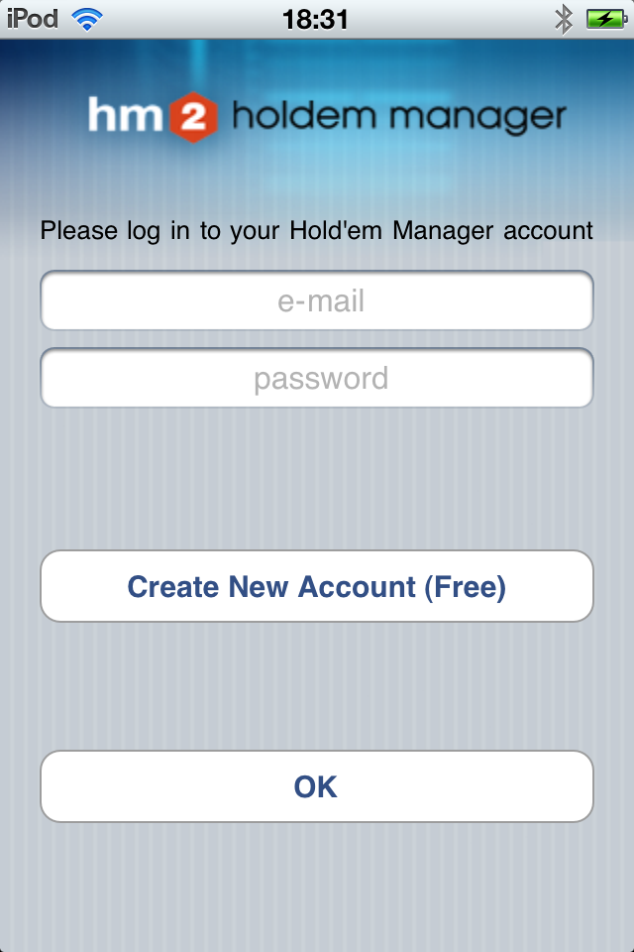
If you do not have an account, click create to create a new account. Once your account is created, sign in to the App with the username and password.
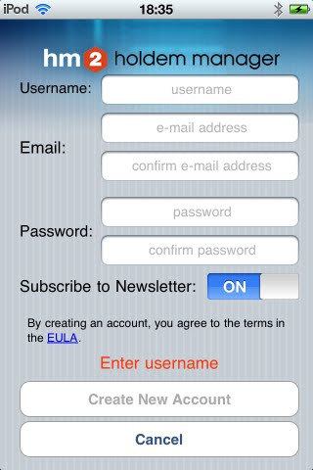
You can sign into the same phone with different accounts. Each account will show the channels, groups and hands saved to that account.

HANDS SCREEN
The Hands screen allows you to manage the hands you have shared to your account. From this screen you can:
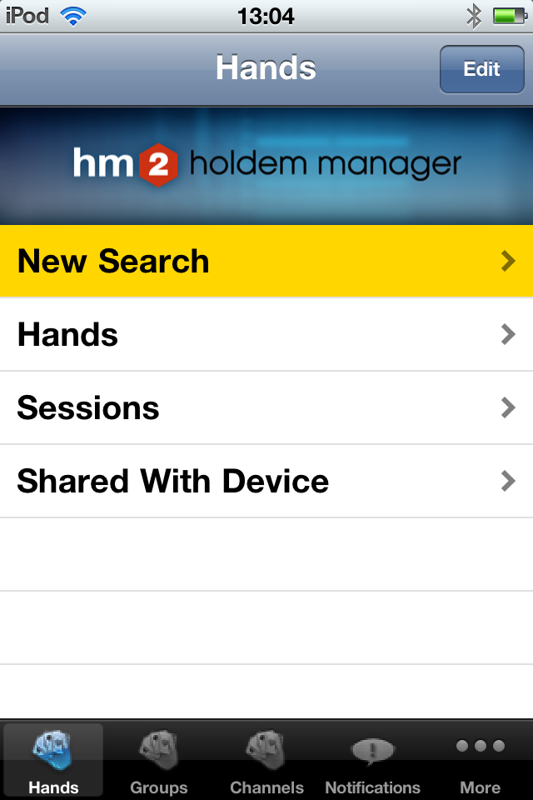

Search hands uploaded to your hm.com database
View all hands in your hm.com database
View sessions uploaded to your hm.com database
View hands uploaded to your iPhone

UPLOADING HANDS FROM HOLD’EM MANAGER 2

Setting up your hm.com account in HM2
From Hold’em Manager 2 Dashboard, open settings.
Click HM.COM Website Login
Type in your registered email and login and save.

To upload a hand, open the Report Tab and select a hand you wish to upload. Right click the hand and select "Upload to Mobile."
You can also upload hands directly from the replayer by clicking the Mobile button in the bottom right
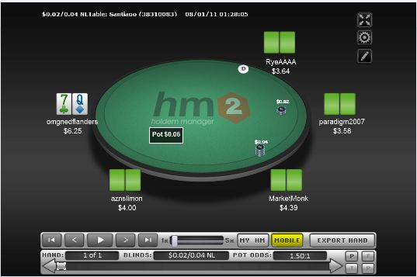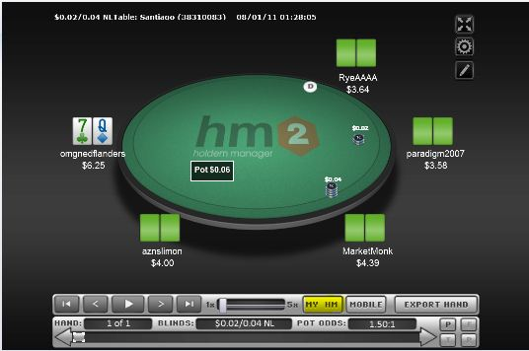
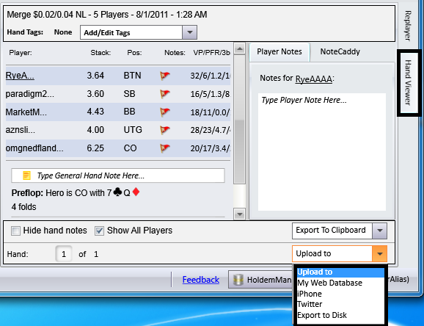

PUBLIC HANDS
Public hands is a database of hands Hold’em Manager users have shared. You can view all of these hands or search through them.
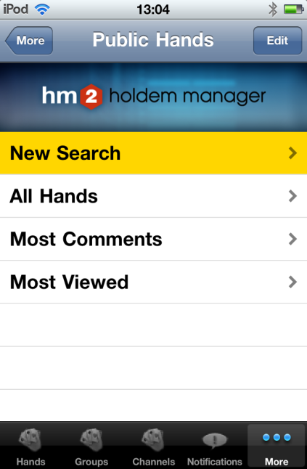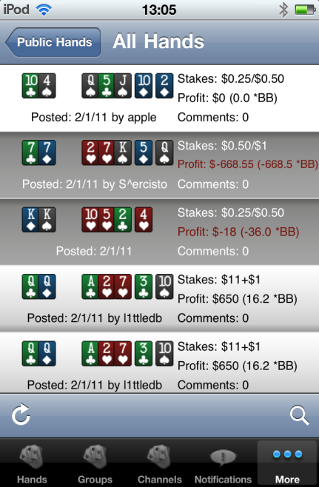

Searching hands
To search for hands, touch New Search on the Public Hands tab, or touch the magnifying glass in the corner in the hands database. This will bring up a list of criteria by which you can search for hands in the database.
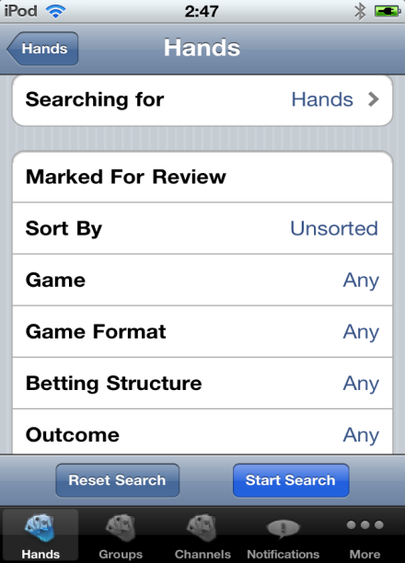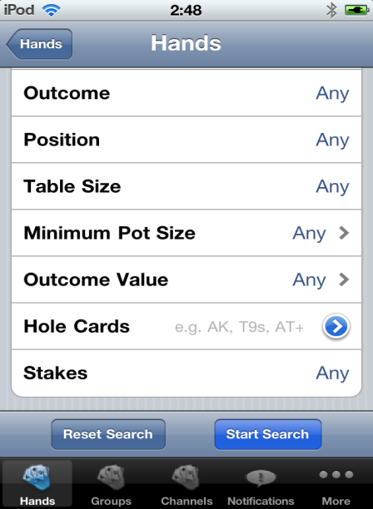
To search, touch any of the criteria, and choose your desired search parameters. This will narrow the hands to just the ones you wish to view.

COMMENTING ON HANDS
As part of a group or channel, you can comment on hands shared and view others’ comments. This allows you to discuss hands on the go with a network of poker players.

To view comments, touch the “number of comments” tab
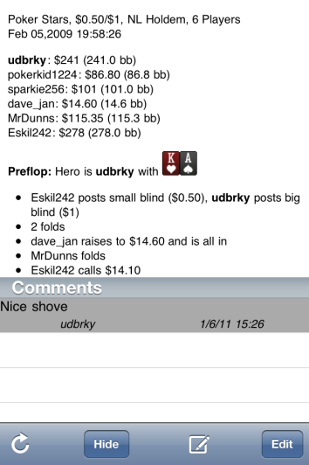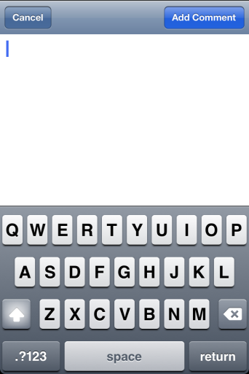
Touch the pencil tab to bring up the keyboard to create the comment, then Add Comment to add it.

VIEWING HANDS
You can view hands you have shared as well as hands shared in the Public Hands database.
Viewing all hands or searching will provide hands you can view.
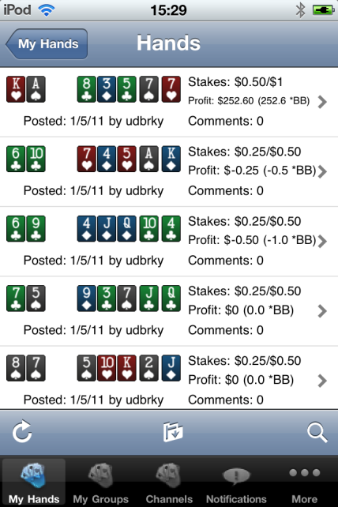
Touch the hand you wish to view and you will see the hand history, with options to make comments or play. Touch play to see a visual replay of the hand in a virtual table.
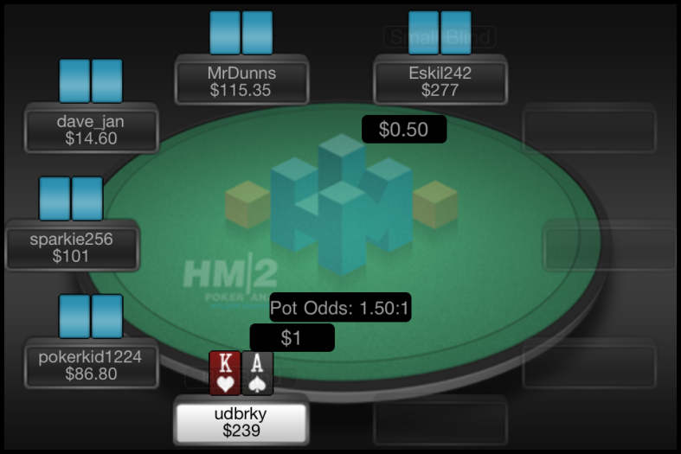

SHARING HANDS
Once you have uploaded a hand to either your holdemmanager.com database or shared it with your iPhone, you can share it with a group or channel. To do so, you must first share it with the public database.
Next find the hand in the public database. Touch the hand you wish to share.
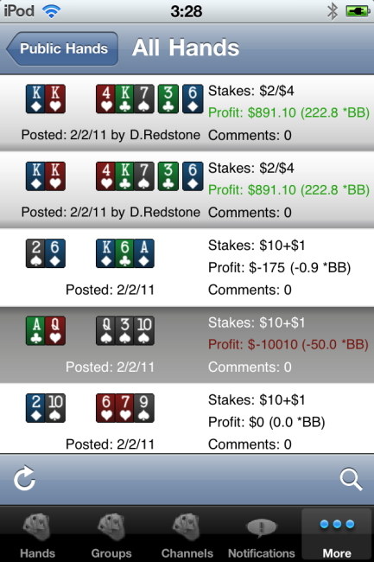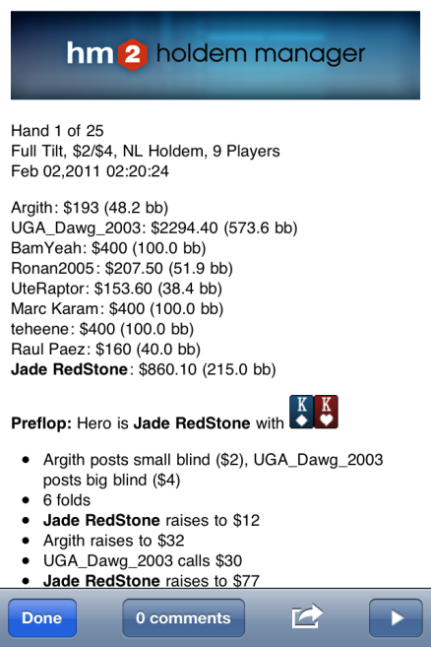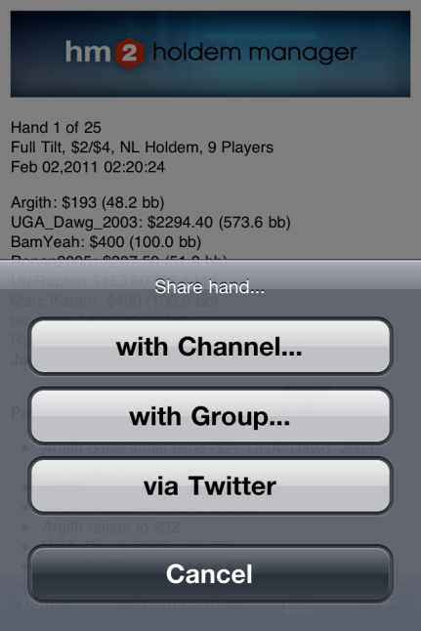
Touch the Arrow tab. This brings up the sharing options. You can share with a channel, share with a group, or share via twitter.
Once you have chosen where to share the hand, click done on the hand history screen to go back to the list. Hand will then be visible to the members of the community with which you have shared it.

GROUPS
Once you create an hm.com account, you automatically have a private group. You can invite friends to join this group via the moderate function and share hands with them. You may also create additional groups.
To add a user, touch Moderate. Then Add/Remove User. Add the email address.
To change a group name, touch Change Group Name.
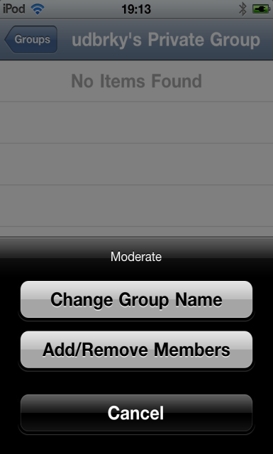

To add a group, touch the + sign in the top right corner in Groups

CHANNELS
Channels are like public groups. Users can subscribe to follow the channel, comment on hands posted and post hands to channels they moderate.

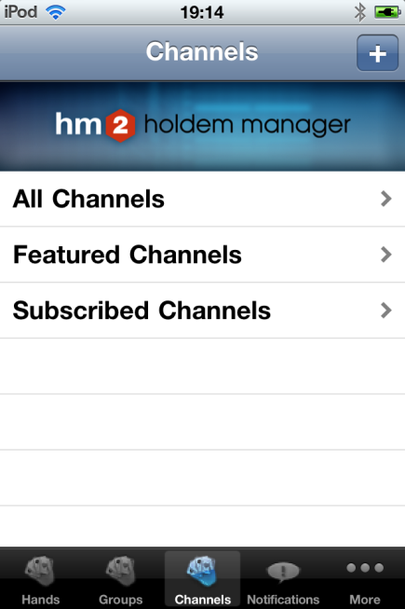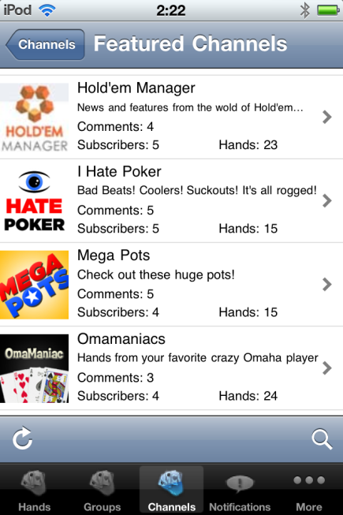

Touch all channels to view available channels to which you can subscribe. Featured channels displays channels Hold’em Manager is featuring. Subscribed channels shows your subscriptions.

NOTIFICATIONS
Frequently, Hold’em Manager will send notices regarding updates to our programs, upcoming features and news from the poker world. In the settings, you can turn on or off notifications.

MORE
This tab contains a database of hands others have share and videos and podcasts we feature, as well as information regarding Hold’em Manager and the iPhone app settings.

VIDEOS
Frequently, Hold’em Manager will release videos designed to help you utilize our tools more efficiently to improve your game.

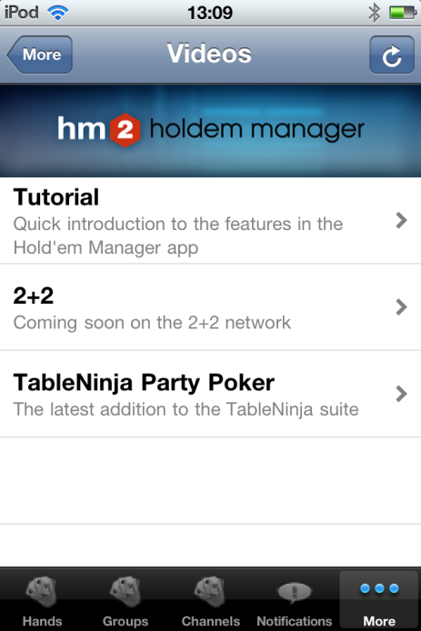

PODCASTS
Frequently Hold’em Manager will share podcasts that you can listen to on your iPhone.

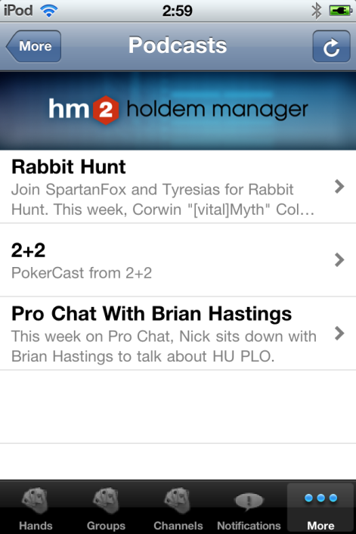

ABOUT

About contains information regarding Hold’em Manager as a company and the iPhone app.

SETTINGS
In settings, you can change various settings for your app and log out of the current account and in as a different user.
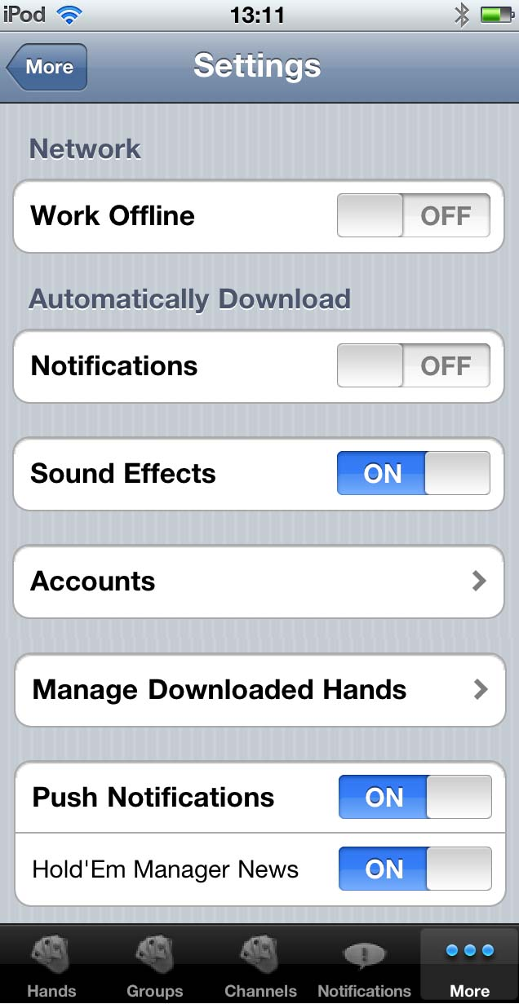

Turn on to view your hands when off the network

Turn on to automatically receive notifications

Turn off to work silently
Manage the logged in account

Delete hands you have uploaded

Manage information you receive

